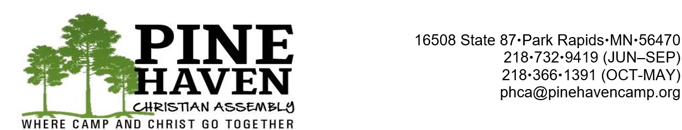

**2025**

**MEMBERSHIP APPLICATION**

We hereby make application for membership in Pine Haven Christian Assembly, Inc. for 2025. Enclosed herewith is the $100.00 annual membership fee, OR we have Pine Haven in our annual church budget and are presently giving $ __________ per year.

We understand that upon approval of our application by the Board of Directors, we will be entitled to all the privileges and voting rights of said corporation as stated in the Articles of Incorporation and By-Laws.

PROPER NAME OF CHURCH______________________________________________

MAILING ADDRESS OF CHURCH _________________________________________

_________________________________________

By ___________________________________________ Date _____________________

**Applications for 2025 membership are due by December 20th, 2024**

**PLEASE RETURN TO:**

**Pine Haven Christian Assembly**

**16508 State 87**

**Park Rapids, MN 56470**

**THANK YOU**